AM000-Asia-China-Warring States-Eight Arc-4 Bat-8 Cloud-475-221 BCE

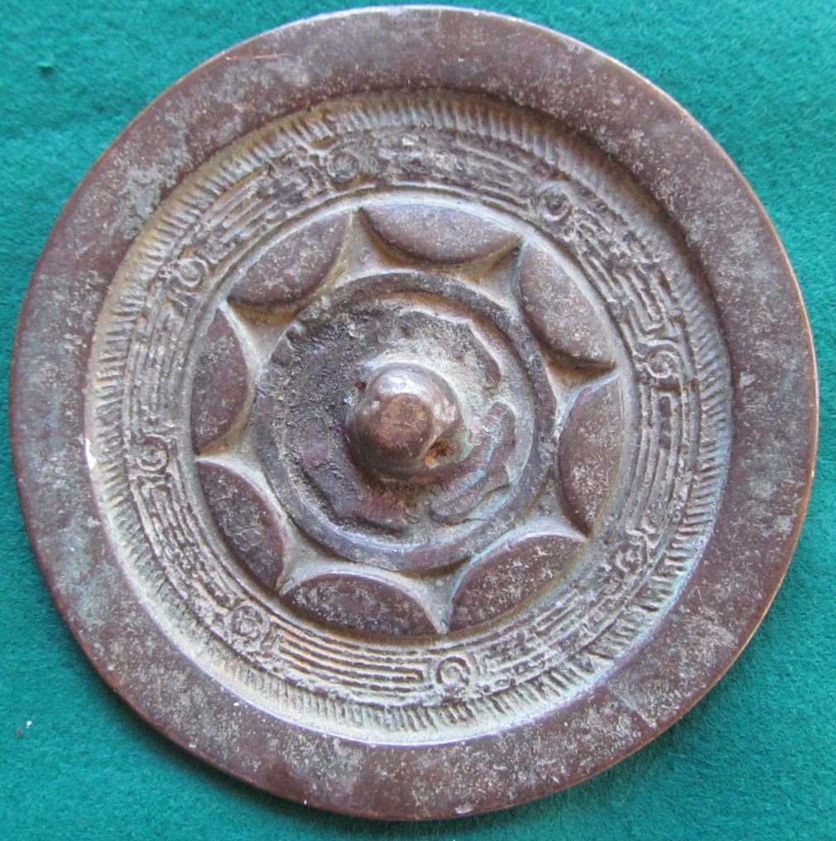

Warring States (475-221 BCE) Mirror. This design features a plain rim, a band of hachuring symbolizing the separation from the unknown void of the cosmos (the plain rim), an 8-segmented cloud motif with a maze design and 8 continuous arcs and a central plain boss surrounded with 4 bat-like arrows.